**Spark Detector Materials List**

**Anode Wire:**

~.003” Tungsten Filament Wire

<http://www.ebay.com/itm/Tungsten-wire-0-1-mm-0-0041-10m-33-ft-/261970207722?hash=item3cfea423ea:g:RlIAAOxyLm9TENQr>

**Anode Wire tie offs:**

.375” X 16ga Brass escutcheon pins

<http://www.mcmaster.com/#97936a132/=12xx2ko>

**Anode Wire Busbars:**

.25” X .50” X 12” Copper or Aluminum bar.

<http://www.mcmaster.com/#8964k4/=12xx5r5>

**Drills for making busbars:**

2 each of:

#55 – McMaster # [30585A71](http://www.mcmaster.com/#30585A71)

#54 – McMaster # [30585A69](http://www.mcmaster.com/#30585A69)

#53 - McMaster # <30585A68>

**Detector Body:**

.75” X 3” X 12” *Natural* Delrin Bar (Black Delrin should be avoided as it contains carbon black and is very slightly conductive.)

<http://www.mcmaster.com/#8739k45/=12xwx2e>

**Cathode Plate:**

.125” X 2” X 12” Aluminum Bar

<http://www.mcmaster.com/#8975k582/=12xx8ah>

Miscellaneous machine screws, taps, mills &c. which I have and we can make use of.

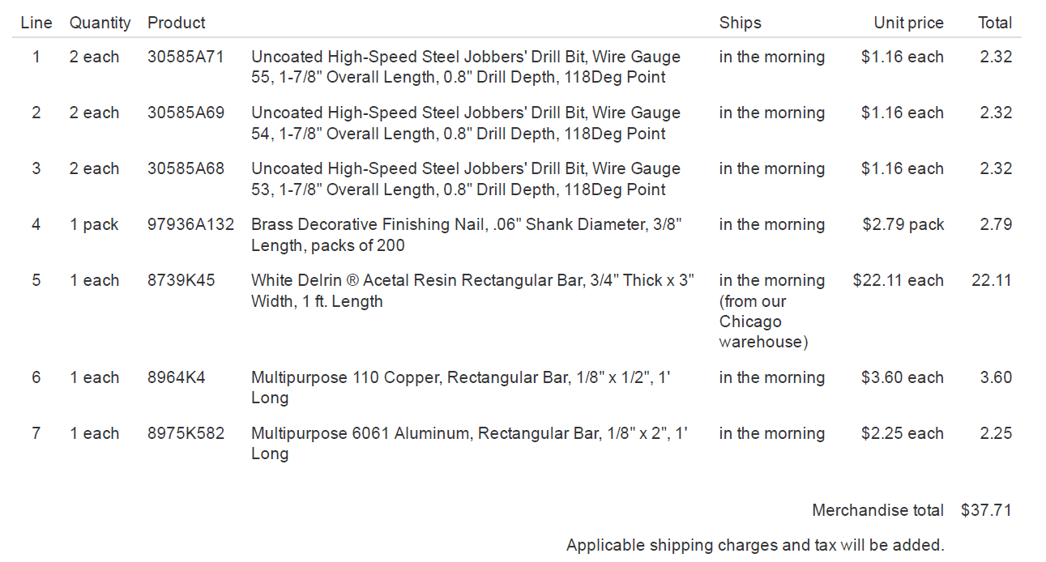Below is the complete McMaster order. The only thing missing is the Tungsten wire, which McMaster caries (#3775K37), but for $106 1/16 lbm.